**STRAY ANIMALS FEEDING MACHINE**

**BY : Himanshu Nagdev(Student ,E.C.E,A.S.E.T,Amity University,Noida)**

**Abstract**

Food is a basic need of every creature. In current scenario NGO’s and people are supporting humanity a lot but hardly anyone is supporting wildlife. Due to lack of access to food, survival of wildlife is becoming difficult day by day. Our invention focuses on solving problem of stray animals like stray dogs, cats etc. some NGO’s and people who have sympathy to feed stray dogs steps away from feeding them because of the fear of bite. So to solve this problem our invention motivates these kinds of people and NGO’s to feed stray dogs by just sitting inside their vehicle. In our invention we have a portable kit that a user can attach and remove from their vehicle. The kit is controlled by a manual button which is will be located inside a vehicle. Now once a button is pressed by a user sitting inside a car then a set of actions will happen inside a kit that will result in fall of disposable then milk in to it. The design and system used in our invention is such that it will let disposable to fall accurately straight so that milk can be filled in to it.

**Brief Description of the Drawings**

**Fig. 1:** This figureshows the extended view of patent without any casing

**Fig. 2**: This figure shows the whole arrangement of the mechanism enclosed in a casing. This is how all parts will be arranged.

**Fig. 3:** SHOOT TANK- it is apiston and cylinder arrangement and act as a mediator between BACK UP TANK and DISPOSABLE FEEDER BOX.

**Fig. 4:** BACK UP TANK **-** in which liquid food is kept

**Fig. 5:** DISPOSABLE FEEDER BOX- consists of stack of disposables and servo motor. Pipe from shoot tank ends here, thus feeding the food.

**Fig. 6:** NRV (Non Returnable Valve) - to avoid any back-flow of material.

**Fig. 7:** High speed motor- attached to pinion in SHOOT TANK

**Fig. 8:** Servo Motors

**Fig. 9:** connecting pipes

**Components List of the Invention**

1. **Backup Tank (Fig. 4)**

The above figure is of BACK UP TANK **(Fig. 4)** in which liquid food is kept inside it. An outlet is also provided with the tank, so that the liquid food can be filled easily. The tank is sealed and airtight by using appropriate arrangements so that it does not harm the quality of the liquid food. One end of the pipe is kept into the tank and the other end is connected to shoot tank. A NRV VALVE fitted in between, for the unidirectional flow of liquid food.

1. **Shoot Tank** (**Fig. 3**)

The shoot tank comprises of a piston and a cylinder arrangement. The piston is threaded and is meshed with the pinion as shown in the figure. One end of the cylinder is engaged with the piston and the other end is connected to pipe which runs into the Disposable FEEDER BOX **(Fig. 5)**. A Non Returnable Valve (NRV) is fixed in the pipe connecting SHOOT TANK (**Fig. 3**) and the DISPOSABLE FEEDER BOX **(Fig. 5)**, to avoid any backflow. The pinion is mounted on the shaft of the high speed motor, as the pinion rotates in anticlockwise direction the piston will move outwards, thus sucking the fluid in the BACK UP TANK **(Fig. 4)** into the cylinder keeping one NRV closed (between SHOOT TANK (**Fig. 3**) and the DISPOSABLE FEEDER BOX **(Fig. 5)**) and other NRV opened (between BACK UP TANK **(Fig. 4)** and SHOOT TANK (**Fig. 3**)). The clockwise rotation of the pinion will make the piston to move in the forward direction thus pressing the fluid with a force to move to the DISPOSABLE FEEDER BOX through the pipe, thus keeping one NRV opened (between SHOOT TANK (**Fig. 3**) and the DISPOSABLE FEEDER BOX **(Fig. 5)**) and other NRV closed (between BACK UP TANK **(Fig. 4)** and SHOOT TANK (**Fig. 3**)).

1. **DISPOSABLE feeder box (Fig. 5)**

This figure is the detailed description of the DISPOSABLE FEEDER BOX **(Fig. 5)**. The DISPOSABLE feeder box is a hollow case which is capable holds the stack of disposable. The servo motors S1 and S2 plays the pivotal role in dropping the disposable from the box to the ground. As the servo motor rotates 90 degrees the disposable drops down and as soon as the motor returns to its original position, it holds the remaining stack of disposable. The purpose of servo motor is to drop a single disposable from the stack of disposables at a time. After completing this operation the milk is fed into the disposable through the pipe coming from SHOOT TANK (**Fig. 3**).

1. **SERVO motors (Fig. 8)**

The servo motors (S1 and S2) as shown in figure 8, have been arranged in compilation with the DISPOSABLE Feeder Box as shown in figure 5. As soon as the servo motors rotate at 90degrees, a DISPOSABLE will drop down. As soon as it rotates in opposite direction it will come back to its original position, thus holding the rest of the disposables.

**CONSTRUCTION**

The **Fig.1** show how this dog patent works. We are discussing here, the technology by which our patent works and also explaining the crux of the mechanism.

The BACK UP TANK (**Fig.4**) is where the liquid food is being filled and the one end of the pipe from the SHOOT TANK **(Fig.3)** is placed inside the tank. The tank is air sealed using appropriate arrangements. The other end of the pipe is connected to the SHOOT TANK (**Fig.3**).

The SHOOT TANK **(Fig.3)** is basically a piston cylinder arrangement with the piston being threaded and the threaded piston is meshed with a pinion which is mounted upon a high speed motor. The shoot tank has its one end attached to the piston and the other end is fitted with NRV valve (**Fig. 6**). The another side of the NRV valve is connected to the disposable feeder box through the pipe.

The DISPOSABLE FEEDER BOX (**Fig.5**) has two SERVO motors (S1 and S2) attached to its two opposite faces, at the lower end of the box, which can rotate at 90 degrees. The feeder box also contains stacks of disposables in the hollow cylinder. The motor attached to the gear and the servo motors (s1and s2) are connected to the motor shield. The motor shield is connected to the microcontroller. The manual control of the system is enabling the microcontroller to rotate motors in a desirable fashion so as to achieve a task. The whole mechanism is power driven by an external battery source.

**WORKING PRINCIPLE**

As soon as we switch on the manual control, a program will be generated inside the microcontroller resulting into mechanism. The mechanism will work in the following manner

**First of all the servo motors (s1 and s2) will rotate at 90 degrees**. The rotation of the servo motors will cause a single DISPOSABLE to drop from the DISPOSABLE FEEDER BOX (**Fig.5**). The servo motors will get back to its original position thereafter, thereby holding the rest of the disposables in stack.

**Second, the motor attached to the pinion, will run at a very high speed**. The arrangement is so done that as soon as the pinion rotates in the anticlockwise direction the piston will move backward and due to this a pressure will be generated in the SHOOT TANK **(Fig.3)** and the milk will be sucked from the back up tank. The volume of the milk sucked will be nearly same as that of the volume of the disposable dropped from the DISPOSABLE FEEDER BOX (**Fig.5**). During this process one NRV is closed (between SHOOT TANK and the DISPOSABLE FEEDER BOX ) and other NRV is opened (between BACK UP TANK **(Fig. 4)** and SHOOT TANK (**Fig. 3**)).

The motor when rotates in clockwise direction will make the piston to move forward and hence pushes the fluid in to the DISPOSABLE FEDDER BOX with a force via pipe between shoot tank and disposable feeder box.in this process disposable get filled with milk and thus food is ready for stray animal.

**Drawings and their Description**

The **Fig.2** shows the whole arrangement of the mechanism enclosed in a casing. The casing has an inlet for the filling of the liquid food inside the BACK UP TANK (**Fig.4**) and also there is a cavity in which the stack of disposables can be fitted inside the DISPOSABLE FEEDER BOX (**Fig.5**).

**Images**

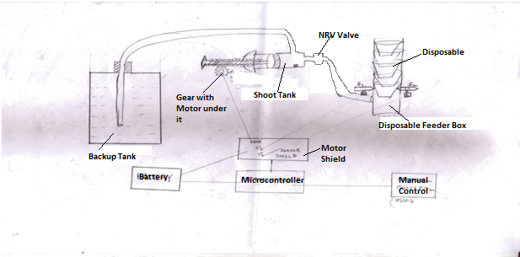

**Fig.1**

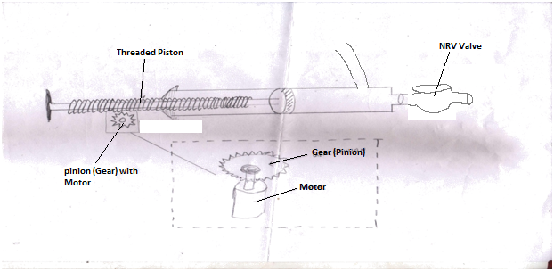

**Fig.3**

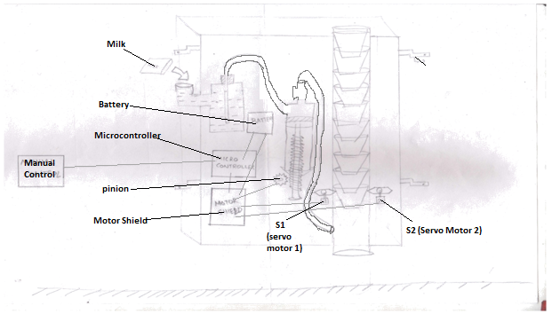

**Fig. 2**

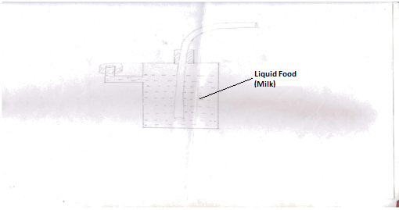

**Fig.4**

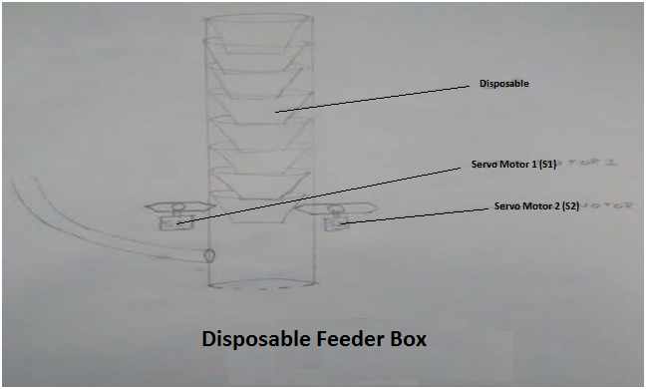

**Fig. 5**

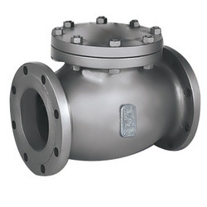

**Fig. 6**

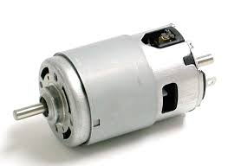

**Fig. 7**

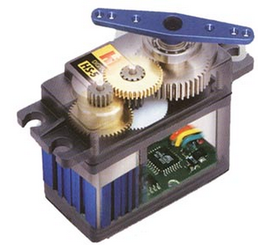

**Fig. 8**

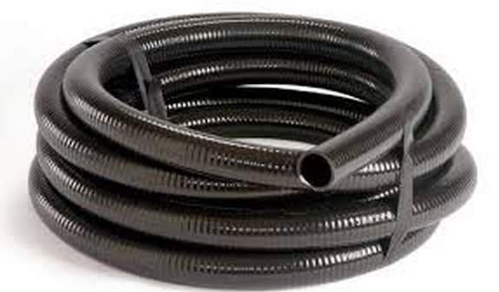

**Fig.9**

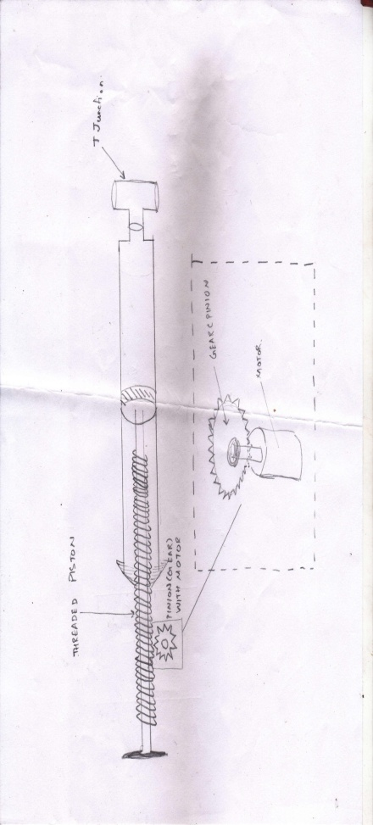

**Claims**:

1. 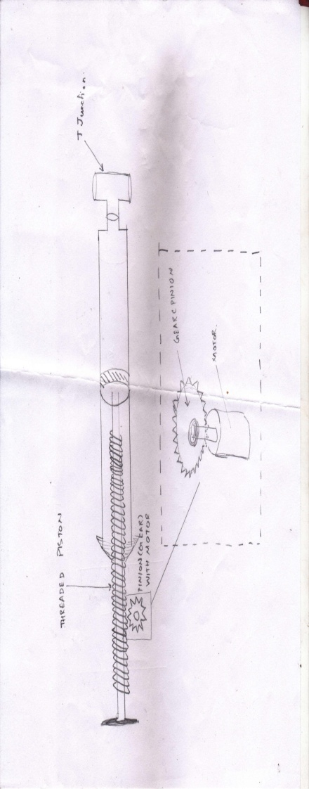No risk of dog bite
2. Serve many stray animals in less time
3. Disposables are easy to feed in machine
4. Milk is also easy to filled in machine
5. This technology motivates ngo’s and people to serve stray dogs.
6. User just need to press a single button inside a vehicle that ready a milk in disposable
7. This technology can serve a dog of almost every local place.
8. No wastage of milk due to the NRV valve technology